Course Name: | Web Development Laboratory (316U01L306) | Semester: | III
Date of Performance: | ___ / ___ / ______ | DIV/ Batch No: | B2
Student Name: | Saanvi Kulkarni | Roll No: | 16010125118

Experiment No: 2
Title: Design web Portal using CSS3.

Aim of the Experiment: To apply CSS3 style sheets to an existing HTML5-based Web Portal for the given Use Case study in order to enhance layout, responsiveness, visual aesthetics, and user interaction using modern CSS3 features.

Objectives for the Experiment:
- Implement different CSS3 styling techniques
- Design responsive layouts using Flexbox and media queries
- Enhance user interaction using animations
- Maintain separation of content and presentation

COs to be achieved:
CO1: Use CSS to prepare the layout of web pages.

Books/ Journals/ Websites references:
- Students should write ……..

Theory:
Students should write about CSS3 (citation needed for content taken (IEEE or APA7 style))

Problem statement: Demonstrate the implementation of CSS3 features to enhance the layout, responsiveness, and aesthetics of the selected HTML-based web portal for the selected Use Case in experiment 1.
Note: All tasks are compulsory to use.

Task 1: Style the Homepage Header (Inline CSS)
Requirements:
- Use inline CSS to:
  - Set background color for header
  - Change text color of store name
  - Center align slogan
  - Add padding and border
- Apply inline style to:
  - <h1>, <p>, <header>
Concepts tested:
Inline CSS, color, background, padding, text-align, border.

Task 2: Internal CSS for Navigation Menu
Navigation menu should look professional and consistent across the page.
Requirements:
- Use internal CSS (<style> in <head>)
- Style navigation menu:
  - Remove bullet points
  - Display menu items horizontally
  - Add hover effect
  - Change link colors
- Use:
  - :hover, text-decoration, display: inline-block
Concepts tested:
Internal CSS, selectors, pseudo-class, styling links.

Task 3: External CSS for Whole Website Theme

For a consistent look across all pages.
Requirements:
- Create file: style.css
- Link it using <link>
- Apply:
  - Body font-family
  - Background color
  - Common heading
  - Common footer style
Concepts tested:
External CSS, reusable styles, site-wide theming.
Deliverables : style.css linked with book.html
Task 4: Style Book Categories Sidebar
The categories section should look like a card.
Requirements:
- Use external or internal CSS
- Apply:
  - Border
  - Box shadow
  - Padding
  - Rounded corners
- Style list items with:
  - Spacing
  - Hover color change
Concepts tested:
Box model, border-radius, box-shadow, list styling.

Task 5: Book Card Layout Using CSS Box Model
To make Each item appear as a product card.
Requirements:
- Style a <div> as a book card:
  - Width, margin, padding, border
  - Center align content
- Use:
  - display: inline-block
  - Add background color and shadow
Concepts tested:
Box model, margin, padding, display property.
Deliverable : link this .css file with book.html
Task 6: Image Gallery Styling with CSS
To make Featured appropriate items/ attributes, whichever applicable in the Use Case look like a grid.
Requirements:
- Use CSS to:
  - Set same size for all images
  - Add border and hover zoom effect
  - Add spacing between images
- Use:
  - transition, transform: scale()
Concepts tested:
Image styling, hover effects, transitions.
Deliverable nav.css , link to nav bar of expt1
Task 7: Table Styling for Price List
Requirements:
- Use CSS to:
  - Collapse borders
  - Add header background color
  - Zebra-striping rows
  - Center align text
- Use:
  - border-collapse, nth-child(even)
Concepts tested:
Table styling, pseudo-classes.
Deliverable table.css , link to the corresponding file.
Task 8: Style Registration Form
Requirements:
- Style:
  - Input boxes width, padding
  - Submit button color and hover effect
  - Fieldset and legend
- Use:
  - :focus, :hover
  - border-radius
Concepts tested:
Form UI styling, pseudo-classes, layout.
Deliverable : form.css
Task 9: Page Layout Using CSS (Header, Sidebar, Content, Footer)
To Create a proper website layout.
Requirements:
- Use CSS to:
  - Set sidebar to left
  - Content to right
  - Footer at bottom
- Use:
  - float or flex
  - Set widths and spacing
Concepts tested:
Layout design, positioning, float/flex.
Deliverable : layout.css

Task 10: CSS Effects & Highlighting.
To attract attention for Special events/data/section, etc..
Requirements:
- Create an “Offer” box:
  - Blinking or glowing effect
  - Different background color
  - Bigger font
- Use:
  - @keyframes animation OR hover effect
  - text-shadow, box-shadow

Concepts tested:
CSS animations, effects, visual emphasis.

Code:

TASK 1:
<!DOCTYPE html>
<!--<style>
p{

font-family:"Lucida Console";
font-size:20px;
}

.center{
text-align:center;
font-size:30px;
color:#355E3B;
}

</style>-->
<head>
<title>Smart Irrigation Advisory System</title>
</head>
<body>
<header id="header" class="main-header"
style="background-color:#355E3B; padding:15px; display: flex; align-items: center; gap: 20px;">
<--<a href="index.html" style="text-decoration: none; flex-shrink: 0;"> -->
<img src="logo.png" alt="Smart Irrigation Logo" style="height: 150px; width: auto; display:inline;">
<--</a>-->
<div style="display: flex; flex-direction: column; justify-content: center;">
<h2 title="Agriculture Organization" style="color: #ECFFDC; margin: 0 0 5px 0; font-size: 1.2rem;" class="center">
KJSSE | KIAAR | Godavari Biorefineries
</h2>
<h1 id="systemName" class="title" title="AI-powered Smart Irrigation Advisory System for Sugarcane Farmers"
style="color: #C1E1C1; margin: 0 0 5px 0; font-size: 1.8rem;"> Smart Irrigation Advisory System
</h1>
<p style="color: #96DED1; margin: 0;">
<strong>Current Crop Season:</strong> Kharif 2026
</p>
</div>
</header>
<nav style="background-color:#f0f0f0; padding:10px;">
<a href="index.html">Home</a> |
<a href="about-system.html">About</a> |
<a href="irrigation-advisory.html">Irrigation Advisory</a> |
<a href="farm-information.html">Farm Information</a> |
<a href="farm-map.html">Farm Map</a> |
<a href="recommendation.html">Recommendations</a> |
<a href="farmer-registration.html">Farmer Registration</a> |
<a href="media.html">Media</a>
</nav>
<!-- ================= MAIN CONTENT ================= -->
<main>
<section id="welcome">
<h2 style="text-align:center; color:#40826D">_______---------- Welcome ----------________</h2>
<p title="Purpose of the Smart Irrigation Advisory System">
The Smart Irrigation Advisory System is an AI-enabled web portal that assists
sugarcane farmers in making informed irrigation decisions using soil moisture,weather forecasts, IoT sensors, and AI-generated recommendations. </p>
</section>
<section>
<h2>Portal Features</h2>
<ul>
<li>Farmer Registration</li>
<li>Farm Information</li>
<li>Weather Monitoring</li>
<li>AI Irrigation Recommendations</li>
<li>Crop Monitoring</li>
<li>Agricultural Awareness</li>
</ul>
</section>
<section>
<h2 style="font-size:30px; text-align:center">Core Objectives</h2>
<ul>
<li>Optimize Water Use:Saves water by only irrigating when necessary.</li>
<li>Maximize Sugarcane Yield:Prevents root rot from over-watering and stunting from under-watering.</li>
<li>Reduce Energy Costs:Minimizes electricity bills by running water pumps efficiently.</li>
<li>Automate Manual Planning:Eliminates guesswork by replacing manual checks with data-driven
scheduling.</li>
</ul>
</section>
</main>
<!-- ================= FOOTER ================= -->
<footer style="background-color:#ECFFDC; padding:10px; text-align:center; color:#40826D;">
<p>
© 2026 Smart Irrigation Advisory System
</p>
</footer>
</body>
</html>

TASK 2:
<!DOCTYPE html>
<html>
<body>
<head>
<style>
.topbar {
height: 50px;
width: 100%;
background-color: #8FBC8F;
}

.spacer {
height: 30px;
}
body {
background-color: #90EE90;
}
h1 {
color: maroon;
margin-left: 40px;
}
ul {
list-style-type: none; /* Removes bullet points */
padding: 0;
margin: 0;
}

.navbar li {
display: inline-block; /* Displays items horizontally */
}

.navbar a {
color: black; /* Link color */
text-decoration: none; /* Removes underline */
padding: 10px 20px;
display: inline-block;
}

.navbar a:hover {
color: white;
background-color: green;
}
</style>
</head>

<div style="height: 50px; width: 100%; background-color: #8FBC8F;"></div>
<h1 style="font-family:impact; font-size: 390%;text-align:center; color: #006A4E "> <u> IRRIGATION ADVISORY PAGE </u> </h1>
<div class="spacer"></div>
<div>
<nav>
<ul class="navbar">
<li><a href="home.html">Home</a></li>
<li><a href="about.html">About</a></li>
<li><a href="services.html">Services</a></li>
<li><a href="contact.html">Contact</a></li>
</ul>
</nav>
<h3 style="font-family: arial; font-size: 200%;text-align:left; color: black "> IMPORTANT IRRIGATION RECOMMENDATIONS: </h3>

<p style= "font-family:verdana; font-size: 150%;text-align:left; color: black; ">
<u>Evapotranspiration (ET) & Moisture-Based Scheduling</u><br>
<ul style="font-family:verdana; font-size: 100%; text-align:left; color: black;">
<li>Calculate Net Water Requirement: Match irrigation volume to crop water loss (ET<sub>c</sub>).
<small> (Apply only the difference between plant water use and effective rainfall.)</small></li>
<li>Maintain the 50% Depletion Limit: Do not allow Management Allowed Depletion (MAD) to exceed 50% of available water
capacity in the root zone before applying the next irrigation cycle.</li>
<li>Monitor Soil Tension: </li>
</ul>
<br>
<ol>
<li> Coarse/Sandy Soil: Irrigate when soil water tension reaches 20–30 kPa.</li>
<li>Medium/Loam Soil: Irrigate when soil water tension reaches 40–50 kPa.</li>
<li>Heavy/Clay Soil: Irrigate when soil water tension reaches 50–70 kPa.</li>
</ol>
</p>
</div>

<div>
<h3 style="font-family:verdana; font-size: 200%;text-align:left; color: black; "><u>WATER CONSERVATION PRACTICES</u></h3>
<p style="font-family:verdana; font-size: 100%;text-align:left; color: black; ">
Smart irrigation methods save water by delivering it precisely when and where crops need it most.
Drip irrigation systems apply water directly to plant roots drop by drop, which drastically reduces evaporation and
wind drift. Implementing high-efficiency Drip Irrigation (DI) systems allows an individual emitter to release just 2,000 cm<sup>3</sup>
to 4,000 cm<sup>3</sup> of water per hour directly to the plant base.
This targeted micro-application cuts farm water waste by 30% to 50% compared to traditional flood methods.
Farmers combine this with <em> data-driven irrigation scheduling and soil moisture sensors to ensure fields are
watered only when actual soil deficits exist, preventing overwatering</em>.Soil and land management practices focus on trapping
moisture directly within the earth. Applying organic mulch, such as straw or wood chips, shields the topsoil from solar
radiation and slows down surface evaporation. Additionally, practicing <em>no-till farming</em> and planting cover crops builds
organic matter, improves soil structure, and significantly increases the land's natural water-holding capacity.

</p>
</div>

<div>
<h3 style="font-family:verdana; font-size: 200%;text-align:left; color: black; "><u>SOME FARMING TERMINOLOGIES:</u></h3>
<p style="font-family:verdana; font-size: 100%;text-align:left; color: black; ">
<small><em>HOVER ON WORDS TO SEE FULL FORMS</em></small><br>
<ul style="font-family:verdana; font-size: 100%; text-align:left; color: black;">
<li><abbr title="GOOD AGRICUTURAL PRACTICES"> GAP </abbr> </li>
<li><abbr title="High Yielding Varieties">HYV</abbr></li>
<li><abbr title="Integrated Nutrient Management">INM</abbr></li>
</ul>

</p>
</div>
<div style="height: 50px; width: 100%; background-color: #8FBC8F;"></div>
</body>
</html>

TASK 3:
<!DOCTYPE html>
<HTML>
<head>
<TITLE>About the Smart Irrigation Advisory System page.</TITLE>
<link rel="stylesheet" href="style.css">
</head>
<BODY>
<div>
<header style="background-color: #355E3B; text-align: center; padding: 5px; border:#355E3B solid 10px ;">
<h1 Style="color: lightgray; padding: 30px;"> ABOUT THE SYSTEM </h1>
</header>
</div>

<div>
<H2><u>OBJECTIVES</u> </H2>
<P>
<UL type="disc">
<LI> Develop an AI-enabled irrigation advisory system for sugarcane cultivation that integrates field observations, weather information, and crop-specific requirements to support informed irrigation decision-making.</LI>
<LI> Monitor soil moisture, environmental conditions, and crop status using sensor networks and geospatial technologies to enable plot-level assessment and precision irrigation management.</LI>
<LI> Generate real-time, forecast-based, and plot-specific irrigation and fertigation recommendations to optimize irrigation scheduling, improve resource utilization, and support operational constraints such as electricity availability. </LI>
<LI> Develop farmer-friendly web and mobile platforms for advisory dissemination, visualization of geofenced plots, crop information management, and decision support. </LI>
<LI> Enhance water use efficiency, reduce yield losses due to water stress, and improve the sustainability and climate resilience of sugarcane farming practices</LI>
</UL>
</P>
</div>
<BR>

<div>
<H2> <u> SYSTEM FEATURES </u> </H2>
<P>
<UL type="disc">
<LI> <B> IoT System </B>for data acquisition </LI>
<LI> <B> AI-enabled irrigation </B>advisory platform</LI>
<LI>Farmer dashboard.</LI>
<LI> <B> Multi-source integrated</B> agricultural data repository.</LI>
<LI> <B> Real-time</B> irrigation recommendation system. </LI>
<LI> Forecasting and alert mechanisms.</LI>
<LI> <B>LLM-based </B> multilingual advisory module.</LI>
</UL>
</P>
</div>
<BR>

<div>
<H2> <u>BENEFITS</u> </H2>
<P>
<UL type="disc">
<LI> Next Irrigation Date Prediction </LI>
<LI>Irrigation Duration Prediction </LI>
<LI>Water Stress Probability Model </LI>
<LI> Rainfall-Adjusted Irrigation Recommendation</LI>
<LI>Yield Loss Prediction Due to Delayed Irrigation </LI>
<LI>Pump Scheduling Optimization </LI>
<LI> Disease and Water Stress Forecasting</LI>
<LI> Yield Prediction Model </LI>
<LI>Farmer-Friendly Advisory </LI>
</UL>
</P>
</div>
<BR>
<body>
<blockquote style="color: white; text-align: center; background-color: #355E3B;">
Smart irrigation helps farmers use water efficiently, improve crop quality, and support sustainable agriculture.
<br><br>
<b>— Agricultural Expert</b>
</blockquote>

<footer style=" text-align: center; padding: 10px;">
<h5 style="color: #355E3B;"> Irrigation Advisory Website. All rights reserved.</h5>
</footer>
</body>
</html>
Style.css:
/* External CSS for whole website theme */

body {
font-family: Verdana, sans-serif;
background-color: #90EE90;
margin: 0;
padding: 0;
}

h1, h2, h3 {
color: #2e6b3e;
}

footer {
background-color:#fff7d1 ;
color: white;
text-align: center;
padding: 15px;
margin-top: 30px;
}

Task 4:
Css file:
body {
font-family: Arial, sans-serif;
background-color: #fff7d1;
}
h1 {
color: darkgreen;
text-align: center;
}

h2 {
color: #555;
text-align: center;
}

h4 {
color: darkgreen;
}
.data-sources {
border: 2px solid darkgreen;
box-shadow: 3px 3px 10px gray;
padding: 20px;
border-radius: 15px;
width: 300px;
background-color: #d6ffc1;
margin: 20px 0;
}
.data-sources h4 {
margin-top: 0;
}

/* Data Sources list */
.data-sources ul {
padding-left: 20px;
}
.data-sources li {
margin: 10px 0;
}
.data-sources li:hover {
color: green;
}
ol li {
margin: 8px;
}
ul > li {
margin: 10px;
}
li li {
margin: 5px;
}
dt {
font-weight: bold;
color: darkgreen;
}
footer {
text-align: center;
background-color: darkgreen;
color: white;
padding: 15px;
}
Code added in html:

<head>
<title>Farm Information and Sensors</title>
<link rel="stylesheet" href="list_css.css">
</head>
<div class="data-sources">
<h4>Data Sources</h4>

<ul>
<li>Soil Moisture Sensors</li>
<li>Weather Forecast</li>
<li>Satellite Images</li>
<li>Crop Information</li>
<li>Soil Reports</li>
<li>IoT Devices</li>
</ul>

</div>
Task 5:
nav.css
/* Book Card */

.book-card {
width: 250px;
margin: 20px;
padding: 20px;
border: 2px solid #355E3B;
background-color: white;
box-shadow: 3px 3px 10px gray;
text-align: center;
display: inline-block;
vertical-align: top;
}

.book-card h3 {
color: #355E3B;
}

.book-card p {
color: #333333;
}

Html code addition:
<head>
<title> Navigation Page</title>
<link rel="stylesheet" href="nav.css">
</head>
……..
<h2>BOOK COLLECTION</h2>

<div class="book-card">
<h3>Smart Irrigation</h3>
<p>Author: John Smith</p>
<p>A guide to modern irrigation techniques and water conservation.</p>
</div>

<div class="book-card">
<h3>Modern Farming</h3>
<p>Author: David Brown</p>
<p>Learn about technology and sustainable practices in agriculture.</p>
</div>

<div class="book-card">
<h3>Precision Agriculture</h3>
<p>Author: Sarah Green</p>
<p>Introduction to sensors, data and precision farming.</p>
</div>
Task 6:
Css code:
.gallery {
text-align: center;
}

/* Same size for all images */
.gallery img {
width: 250px;
height: 180px;
object-fit: cover;

/* Border */
border: 3px solid #355E3B;

/* Spacing */
margin: 15px;

/* Smooth zoom */
transition: transform 0.3s ease;
}

/* Hover zoom effect */
.gallery img:hover {
transform: scale(1.1);
}
Changes made in html:
Added this href link in nav.html
Made a html for image-gallery:
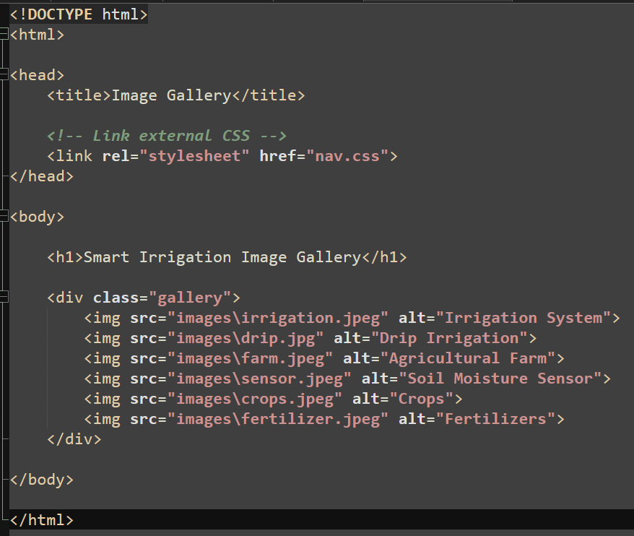

Task 7:
Css code:
table {
width: 90%;
margin: 0 auto; /* Centers the whole table */
border-collapse: collapse;
}

th, td {
border: 2px solid black;
padding: 8px;
text-align: center; /* Centers text inside cells */
}

th {
background-color: #8FBC8F;
}

tbody tr:nth-child(even) {
background-color: #D0F0C0;
}

tfoot td {
background-color: #8FBC8F;
}
Task 8:
body {
background-color: #b9d1a5;
font-family: Arial, sans-serif;
}

/* Form container */
form {
width: 50%;
margin: 30px auto;
padding: 15px;
background-color: white;
border: 2px solid #355E3B;
border-radius: 10px;
}

/* Labels */
label {
font-weight: bold;
}

input[type="submit"]:hover,
input[type="reset"]:hover {
background-color: #228B22;
}
input[type="submit"],
input[type="reset"] {
padding: 10px 25px;
border: none;
border-radius: 5px;
color: white;
background-color: #355E3B;
cursor: pointer;
margin-right: 10px;
}
input[type="text"],
input[type="tel"],
input[type="email"],
input[type="number"],
select {
width: 90%;
padding: 10px;
margin-top: 5px;
border: 1px solid #355E3B;
border-radius: 5px;
}
input[type="text"]:focus,
input[type="tel"]:focus,
input[type="email"]:focus,
input[type="number"]:focus,
select:focus {
border: 2px solid green;
outline: none;
background-color: #F0FFF0;
}

Code added in html:
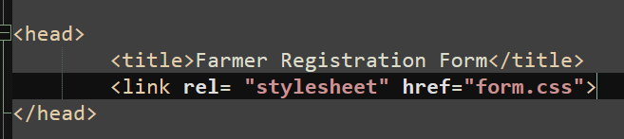
Task 9:
Layout.css:
/* Page Layout */

body {
margin: 0;
font-family: Arial, sans-serif;
}

/* Header */
header {
background-color: #355E3B;
padding: 15px;
color: #C1E1C1;
}

/* Navigation */
nav {
background-color: #f0f0f0;
padding: 10px;
text-align: center;
}

nav a {
text-decoration: none;
color: #355E3B;
margin: 10px;
}

/* Main layout */
.container {
display: flex;
min-height: 500px;
}

/* Sidebar */
.sidebar {
width: 20%;
background-color: #D0F0C0;
padding: 20px;
}

/* Content */
.content {
width: 80%;
padding: 20px;
}

/* Footer */
footer {
background-color: #ECFFDC;
padding: 10px;
text-align: center;
color: #40826D;
}
Html code added:
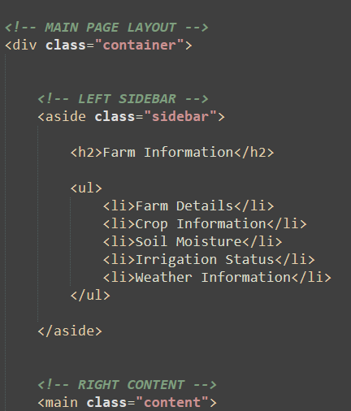

Task 10:
body {
font-family: Arial, sans-serif;
background-color: #f2f2f2;
text-align: center;
padding-top: 100px;
}

.offer {
display: inline-block;
background-color: #ffcc00;
color: #8b0000;
font-size: 28px;
font-weight: bold;
padding: 25px 40px;
border-radius: 10px;

/* Shadow around the box */
box-shadow: 0 0 15px orange;

/* Shadow around the text */
text-shadow: 2px 2px 4px white;

/* Animation */
animation: glow 1s infinite alternate;
}

@keyframes glow {
from {
box-shadow: 0 0 10px orange;
}

to {
box-shadow: 0 0 30px red;
}
}

Html code added:
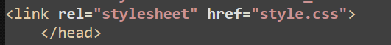

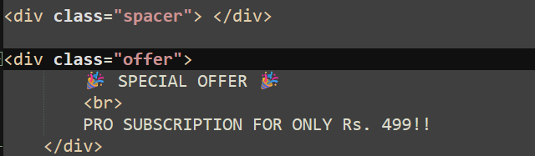

Output / Screenshot:

TASK 1:
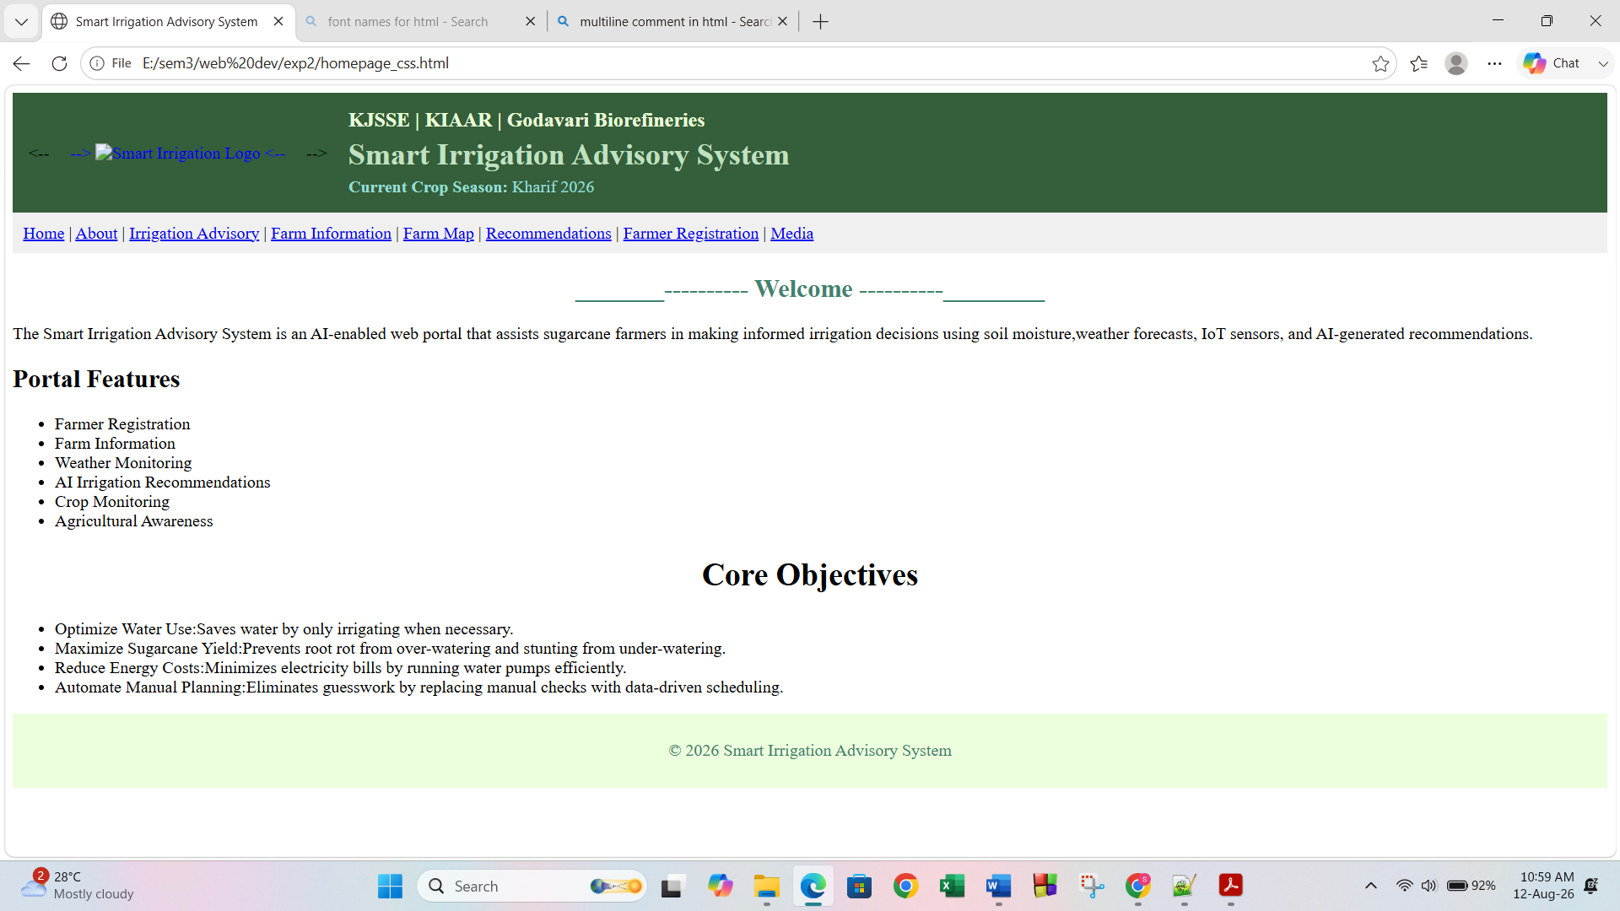
TASK 2:

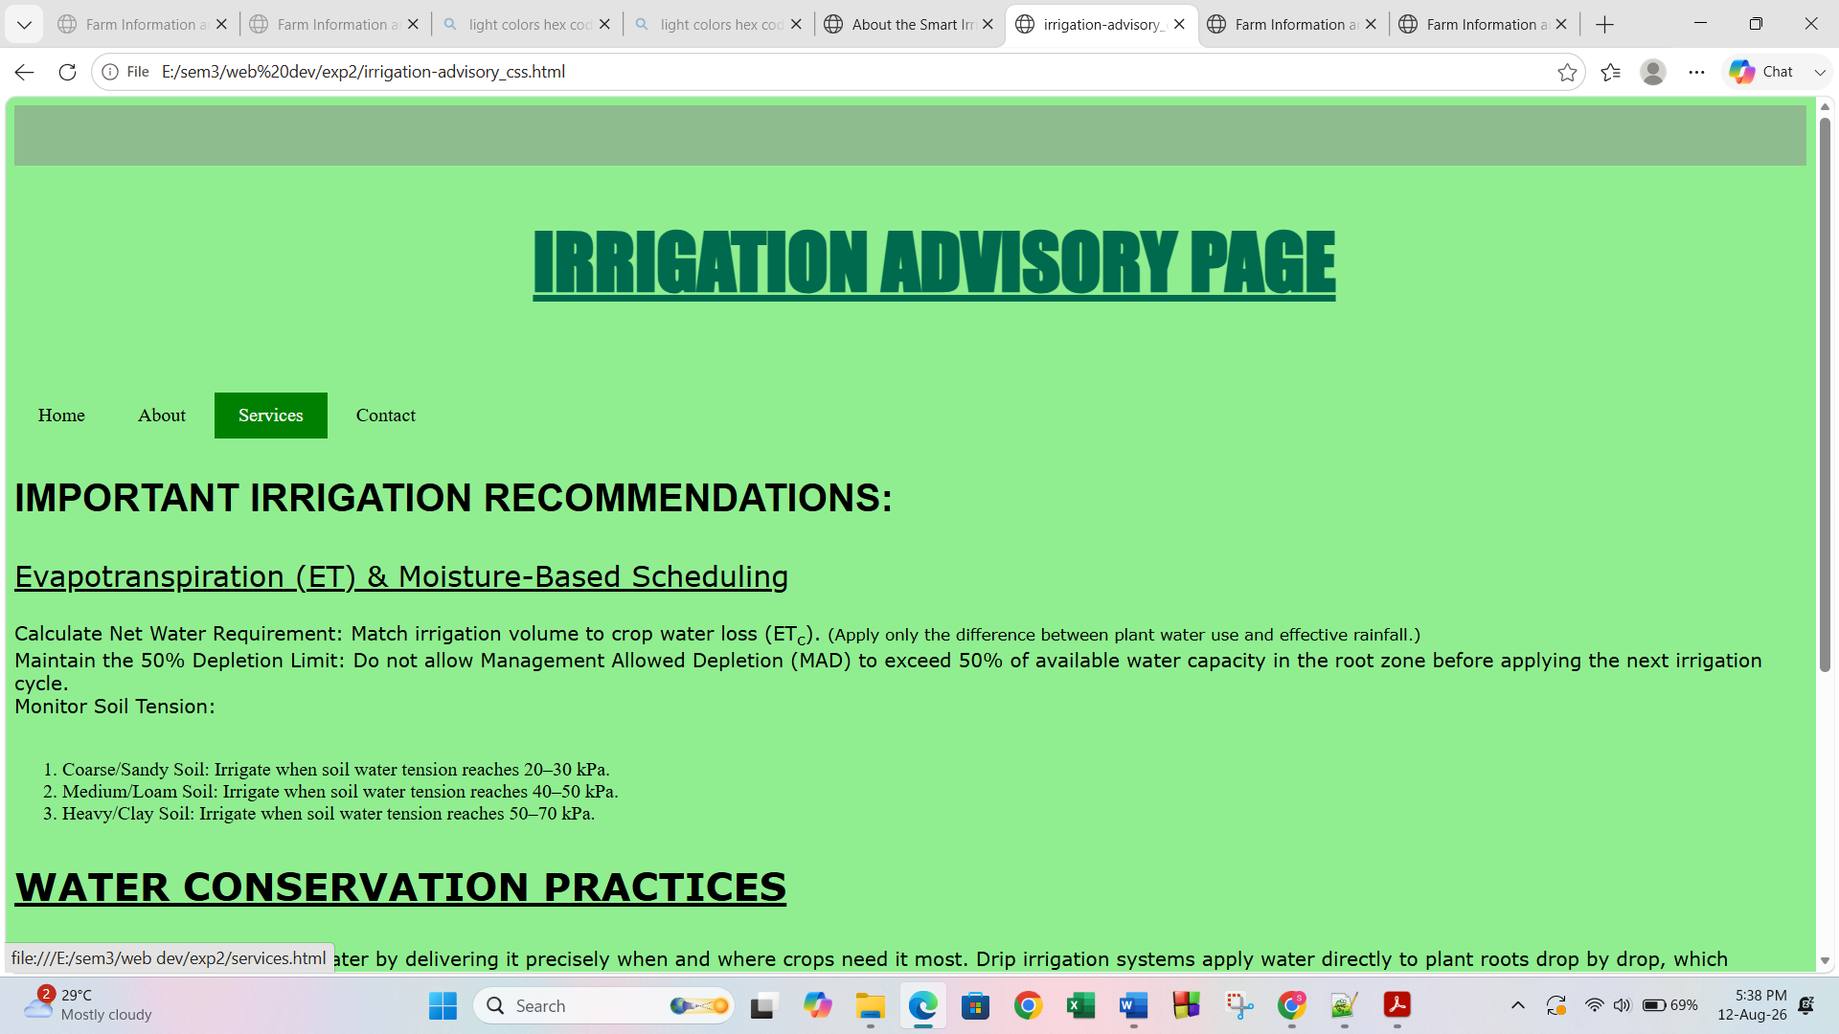

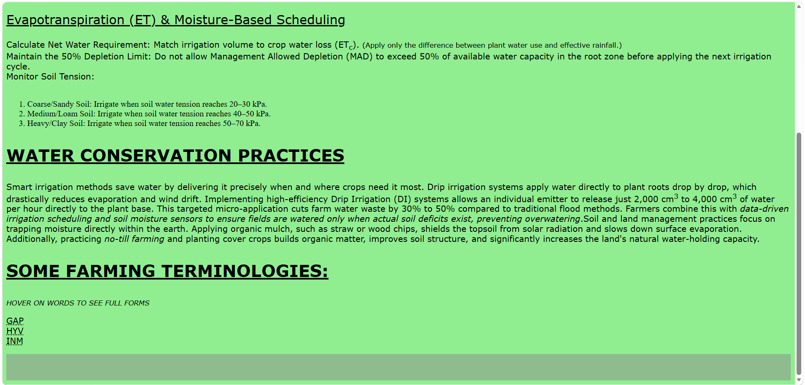

TASK 3:
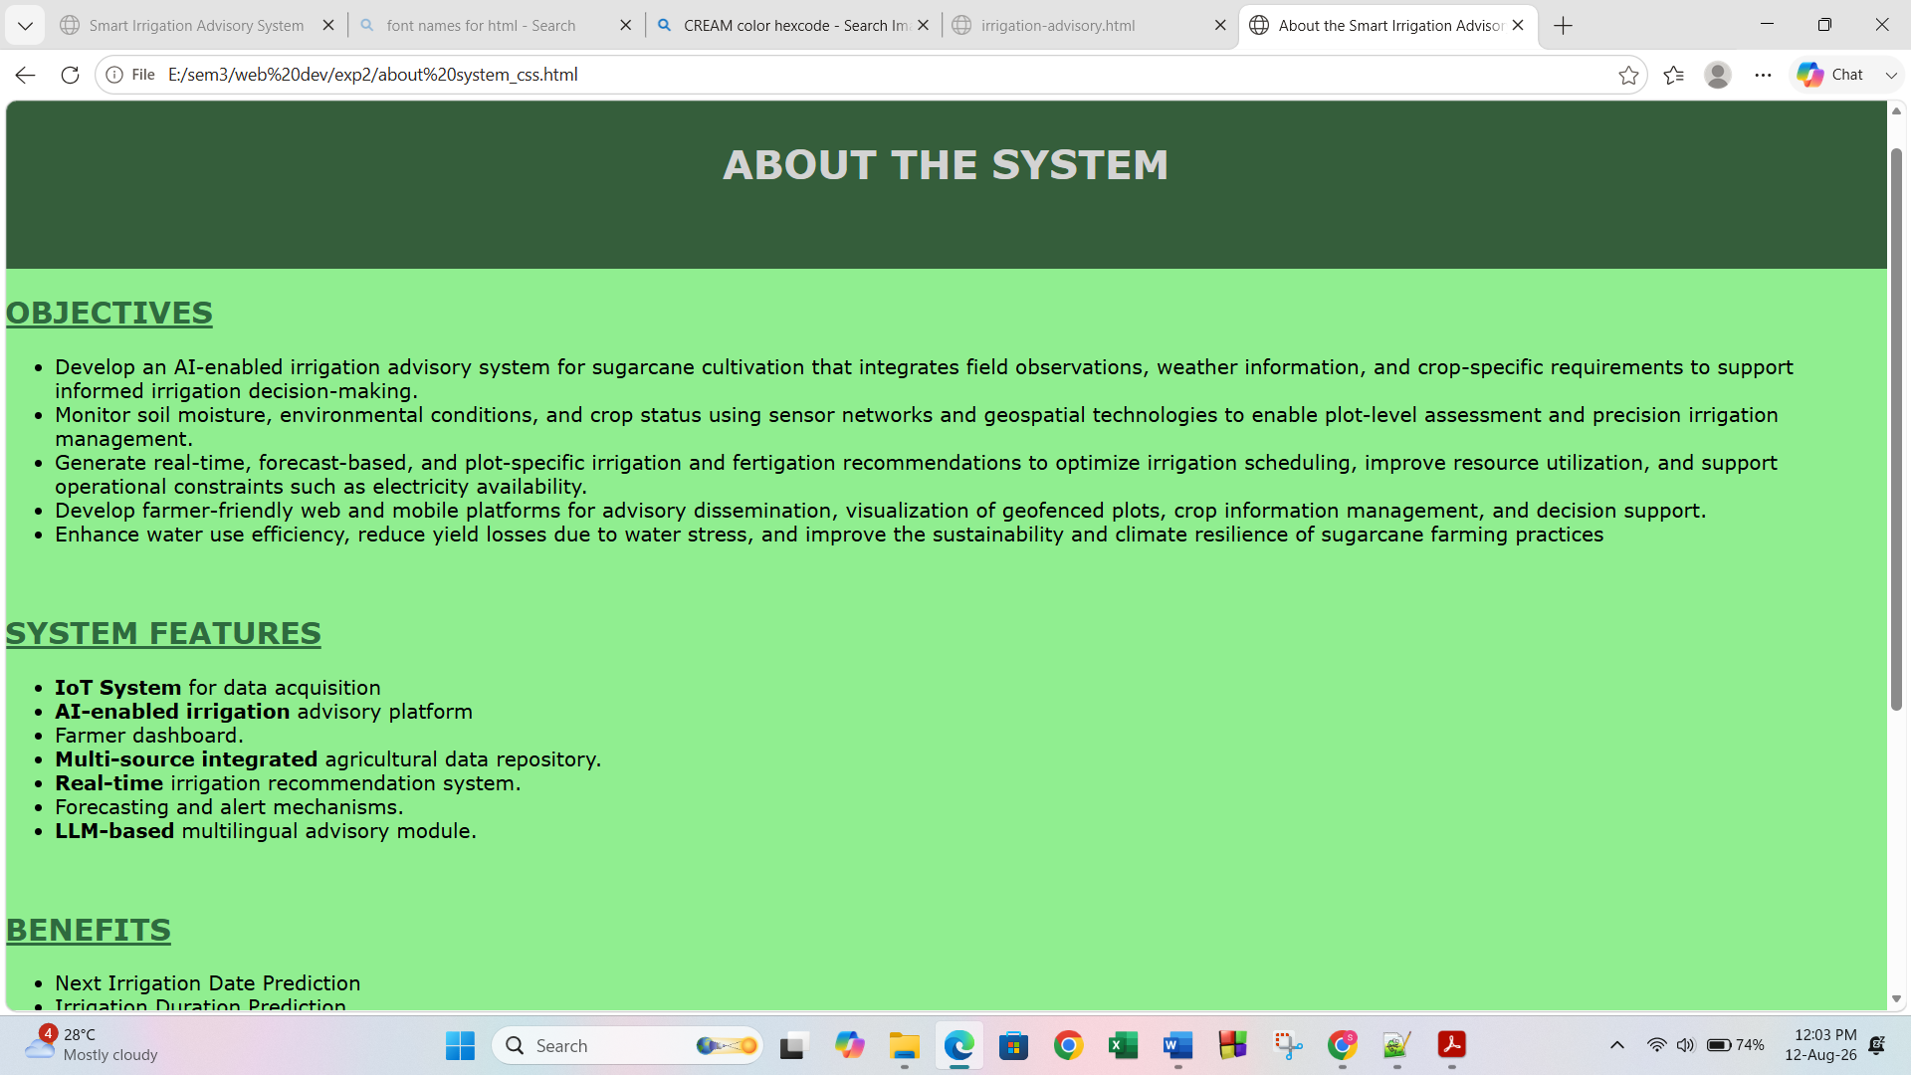
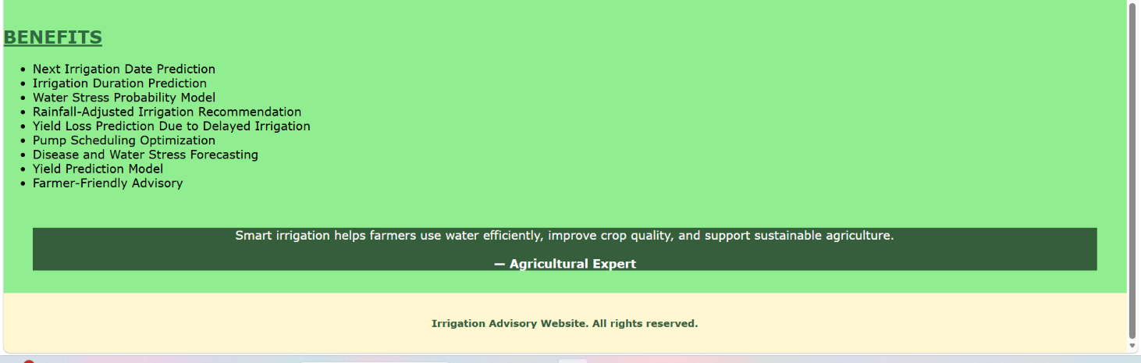
TASK 4:
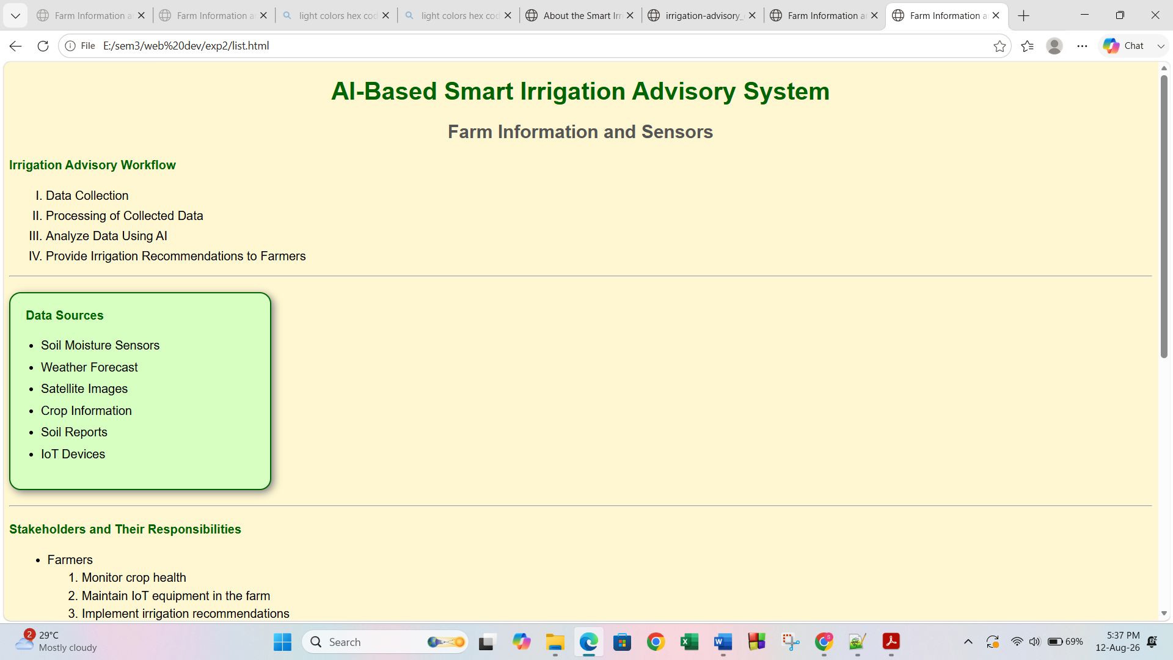
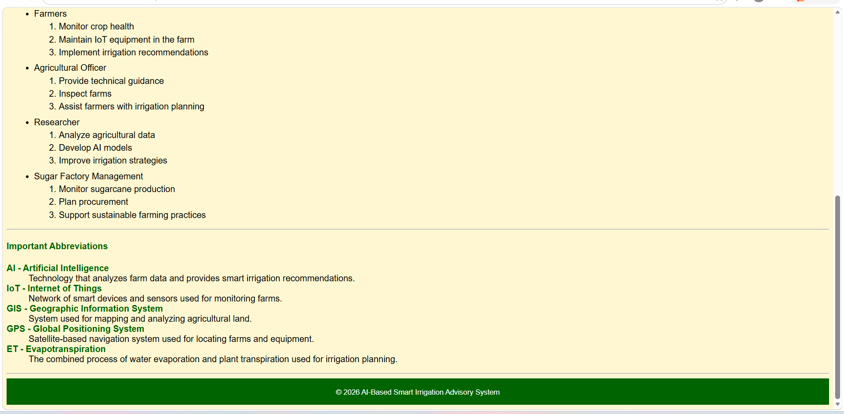

Task 5:

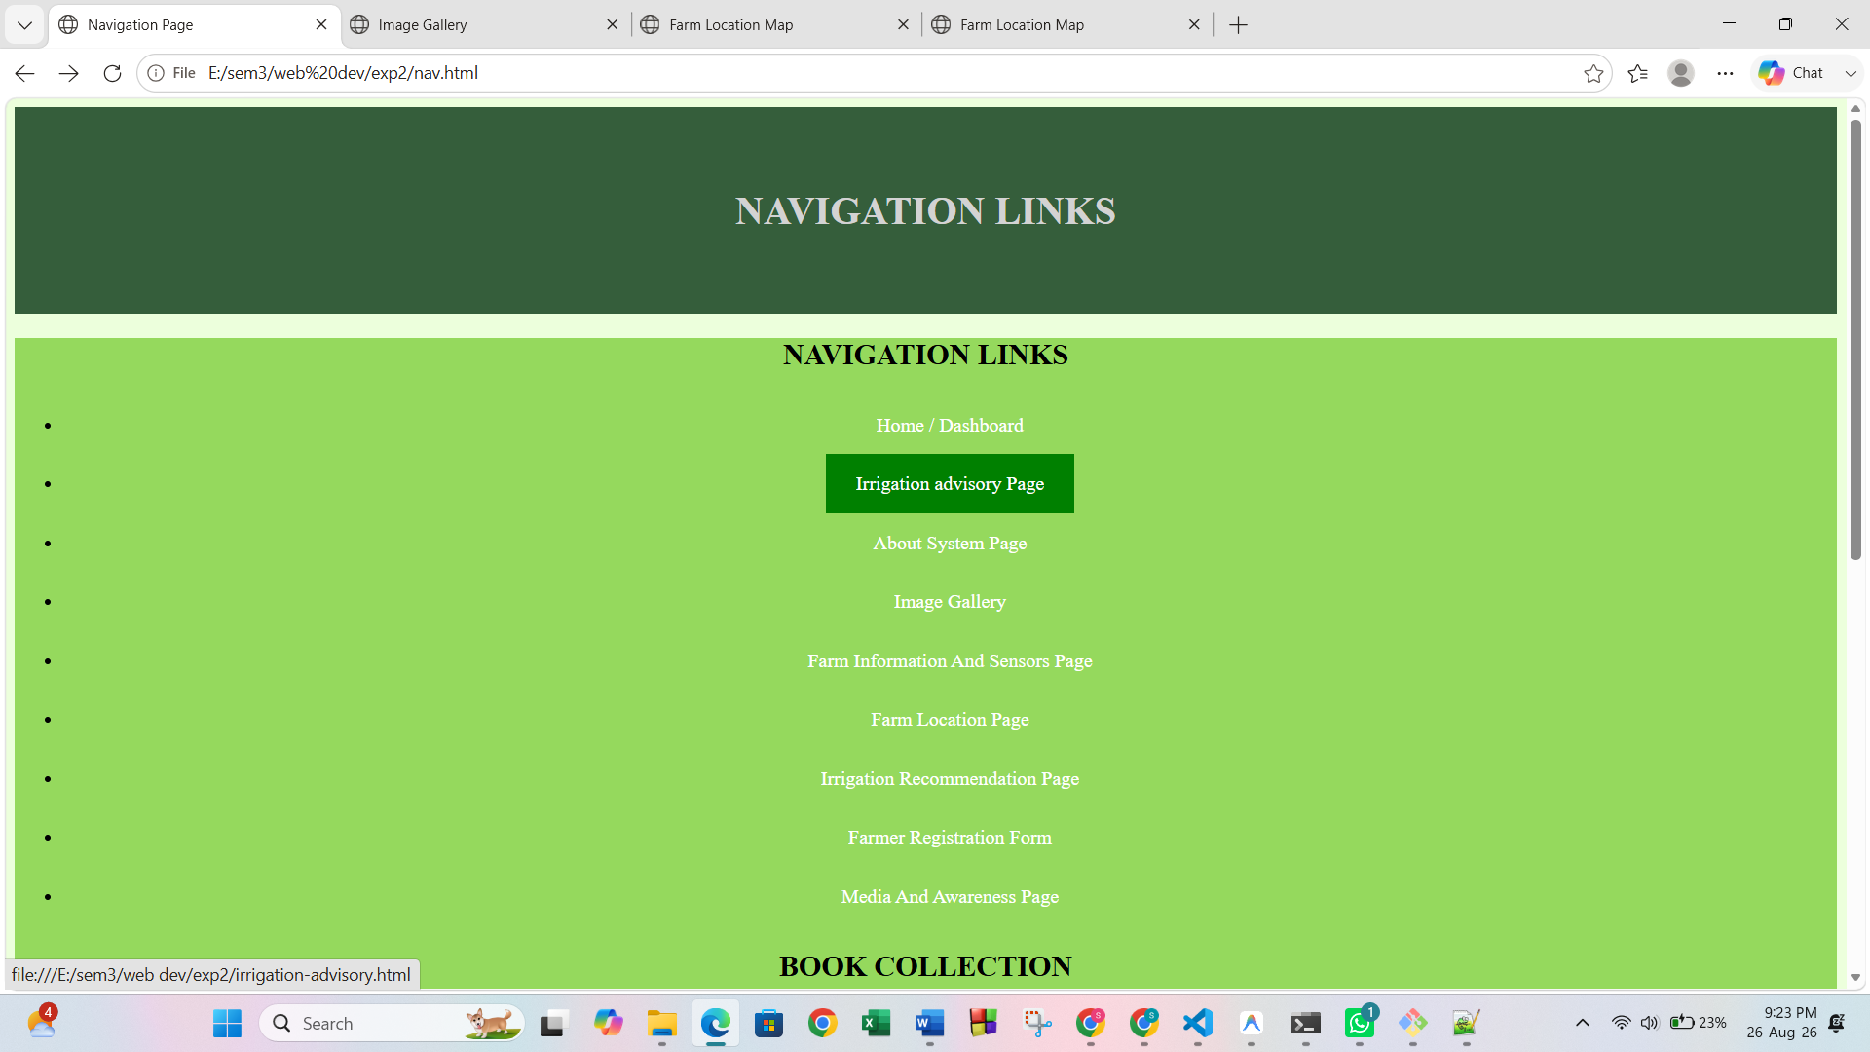

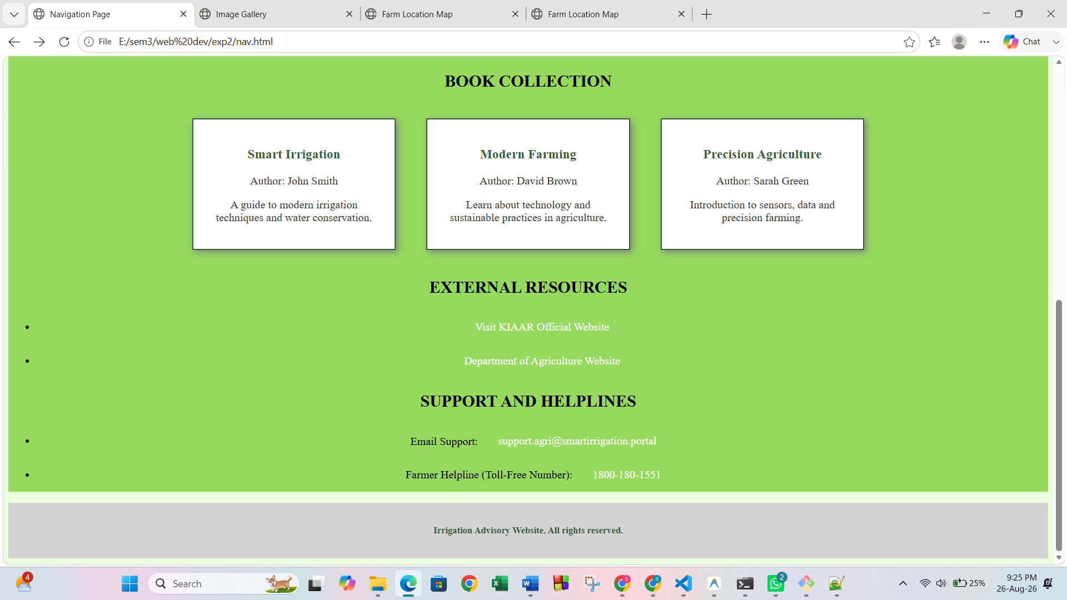

Task 6:
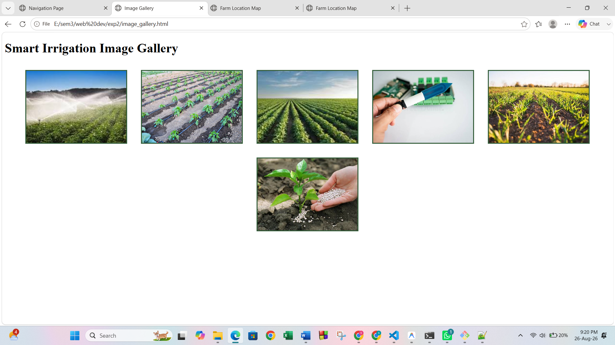

Task 7:

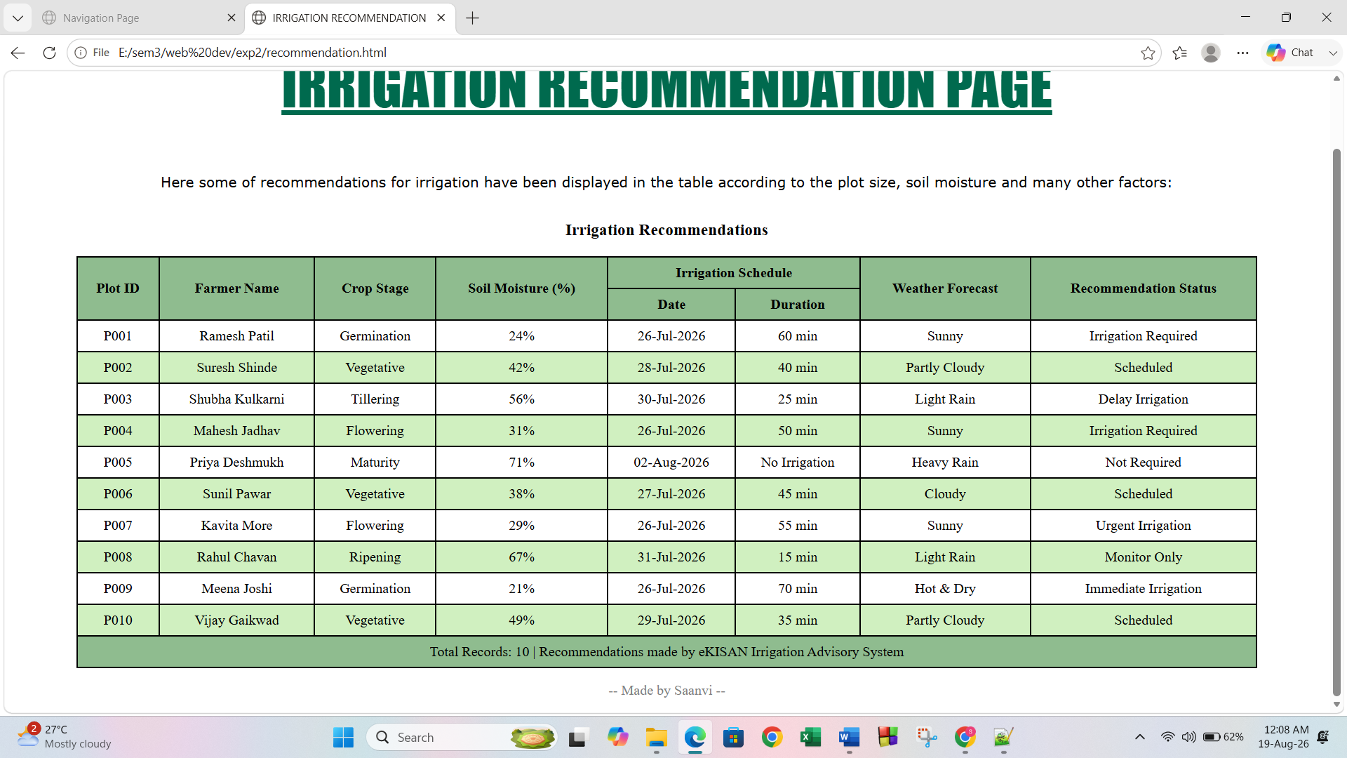

Task 8:

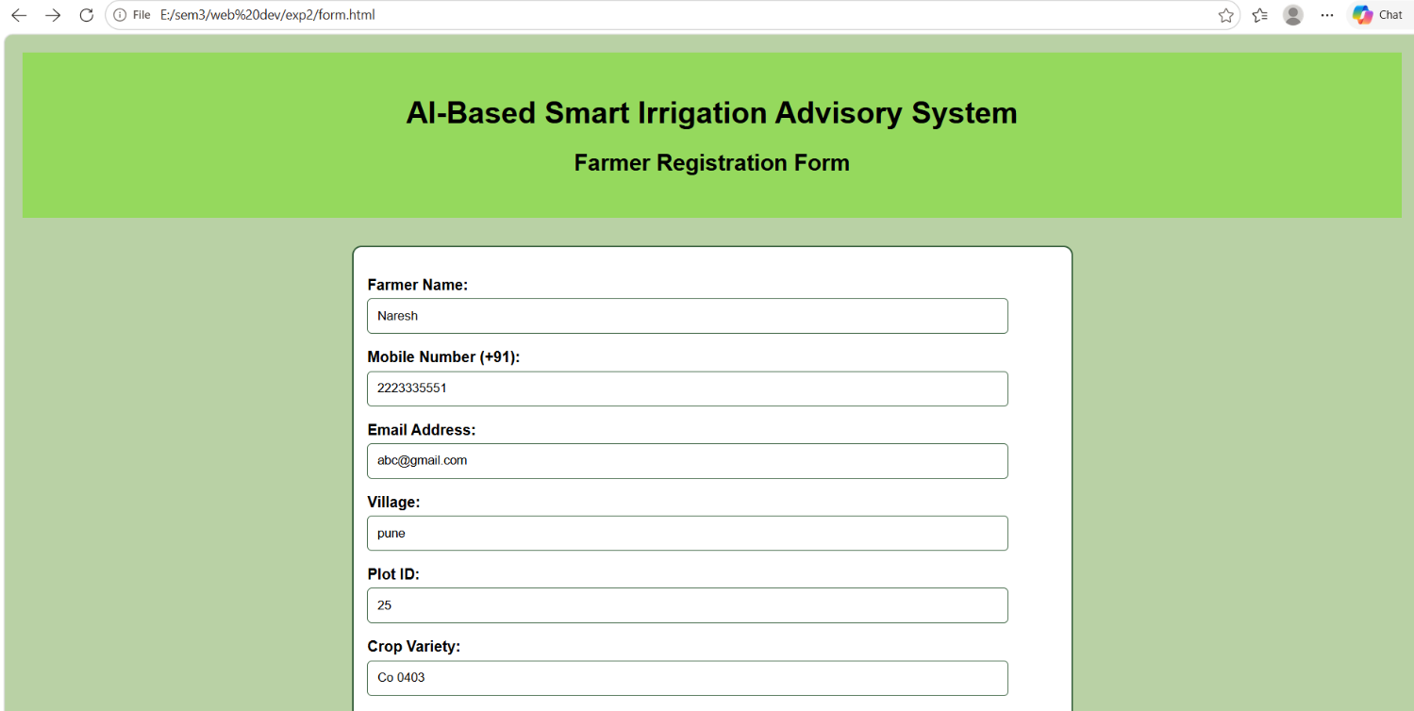
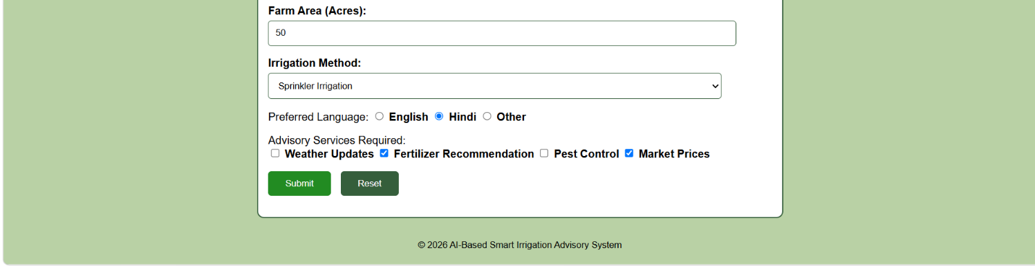
Task 9:
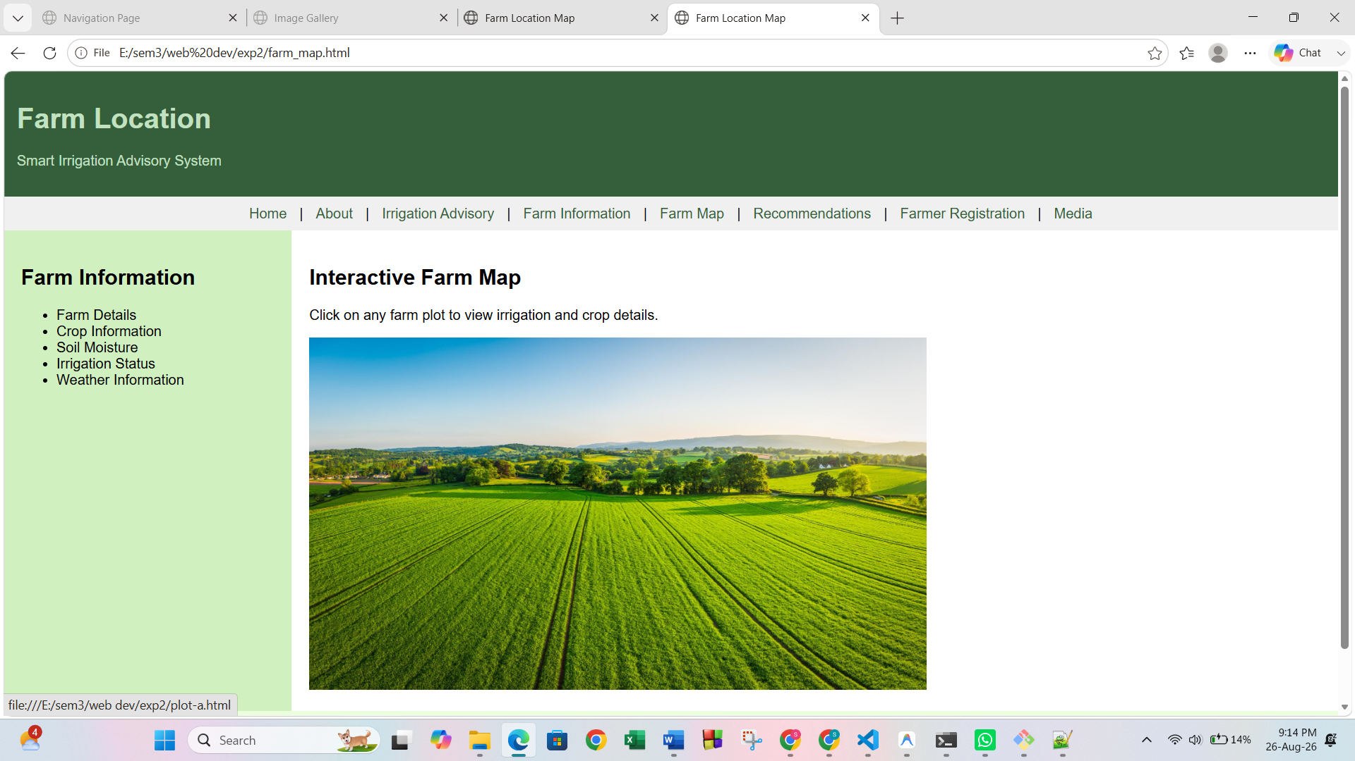
Task 10:

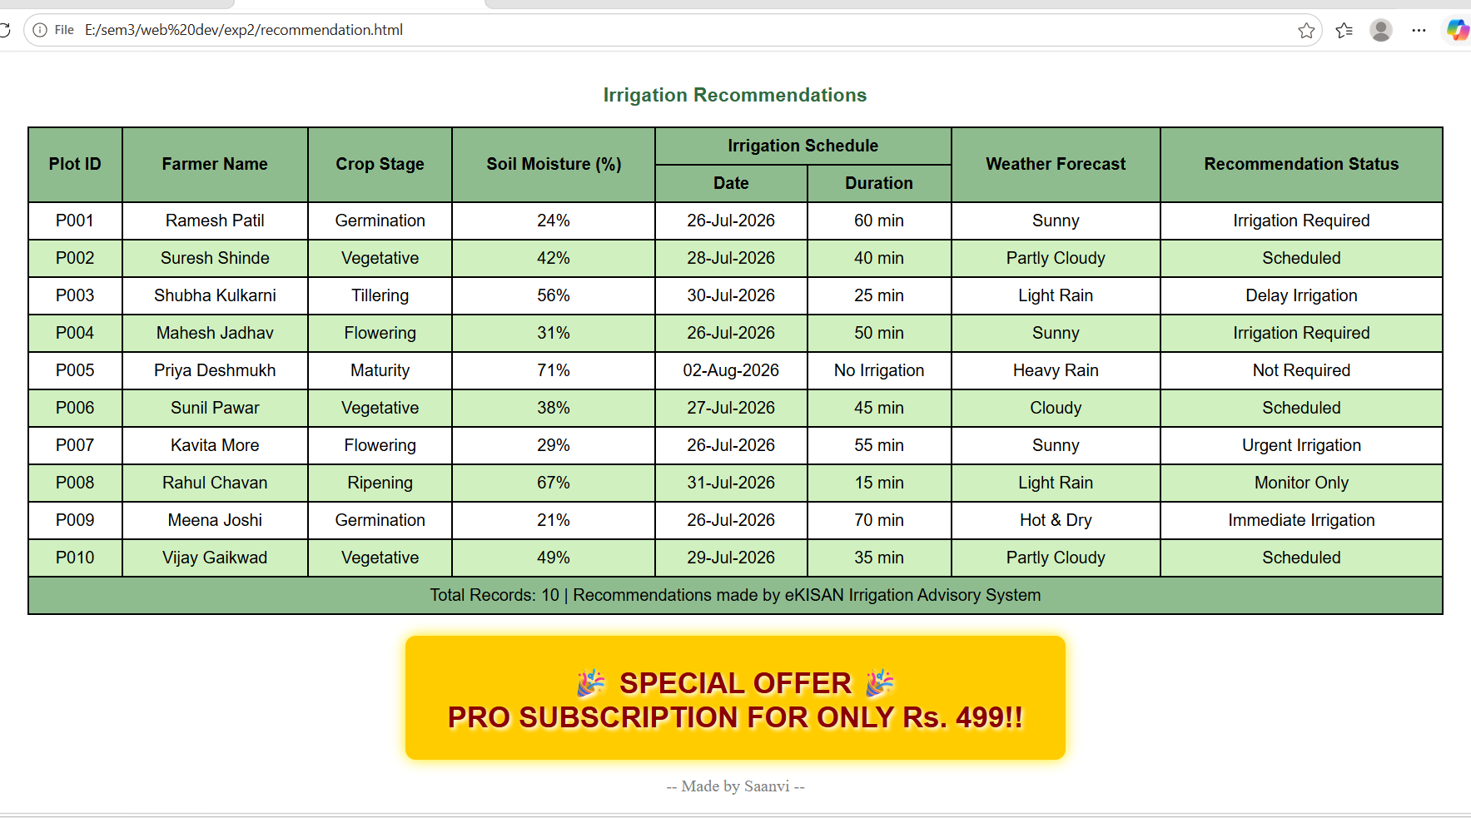

Post Lab Subjective/Objective type Questions:
- Use Bootstrap for CSS.
Bootstrap CSS – Brief Explanation
Bootstrap is a popular CSS framework used to design responsive and attractive web pages quickly. It provides predefined classes for navigation bars, buttons, forms, tables, spacing, colors, and page layouts.
In this task, Bootstrap was used through its CDN link and predefined classes such as container-fluid, row, col-md-3, and col-md-9 to create a layout with a left sidebar and right content area. Classes like text-center, p-4, bg-light, and navbar were used for styling and spacing.
Thus, Bootstrap reduces the need to write CSS from scratch and helps create a consistent and responsive website layout.

Conclusion and Discussion:
(students should write in your words)
(Also get feedback from fellow classmates (minimum 3) and faculty to add here)
Thus, the experiment successfully demonstrated the use of HTML and CSS to design and style different components of a web page. Various CSS techniques were implemented through the different tasks, including internal and external CSS, navigation menus, the CSS box model, table styling, form styling, image galleries, and page layout.

